Bonding Remediation  
____________________________________________________________________________________

Pdf Answers

Ionic Bonding

1. Convert the following formulas and names.



Ionic naming

* 1. CaCO3
  2. CuO

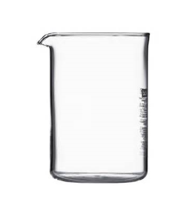

* 1. Cu2O
  2. Aluminum Hydroxide
  3. Iron(III) oxalate



Ionic  
properties

* 1. Ammonium sulfate

1. Aluminum hydroxide dissolves in water
   1. Write the dissolving reaction.
   2. Draw out a particulate drawing in the beaker.
2. Aluminum Hydroxide will have a (greater/less/equal) melting point compared to Aluminum oxide. Justify

Covalent Bonding

1. Convert the following formulas and names
   1. CO2



Covalent   
naming

* 1. NO
  2. N2O5



* 1. Sulfur Hexaflouride
  2. Carbon monoxide
  3. Carbon tetrachloride

1. Ammonia is a common substance in cleaning agents. The formula is NH­3. Answer the following questions.

Covalent   
Properties



* 1. Create a Lewis structure.
  2. What is the electronic structure?
  3. What is the molecular structure?
  4. Is there a polar bond?
  5. Is the substance polar?
  6. In the beaker to the right draw a sample of liquid ammonia. Label the intermolecular force

6. Carbonate:

a. Write out a Lewis structure.

b. What is the bond order of the bond in carbonate?

c. How many electron domains are present?

d. What is the electronic shape?

e. What is the molecular shape?

f. Is this substance polar?

g. If carbonate were vaporized to a gas, what IMF would be broken?

7. Nitrogen gas (N2)

a. Draw out a Lewis structure.

b. Does this substance have a dipole moment?

c. What IMF is formed when N2 is condensed in a liquid?

------------------------------------------------------------------------------------------------------------------------------------------

8. The lipid bilayer is a component of every cell in the human body. Based upon the drawing provided explain and identify what and why the forces here.

